Page Replacement Algorithm Simulator Report

1. Introduction

This report details the development and implementation of a web-based Page Replacement Algorithm Simulator, designed to page visualize and compare three page replacement algorithms:
- First-In-First-Out (FIFO)
- Least Recently Used (LRU)
- Enhanced Second Chance (ESC)
The simulator provides an interactive interface for users to input a page reference string and the number of memory frames, allowing step-by-step or full simulation of these algorithms. The primary goal is to demonstrate how each algorithm manages memory pages, tracks page faults and hits, and provides visual feedback to enhance understanding of operating system memory management concepts. The simulator is built using web technologies to ensure accessibility and ease of use, with a focus on clear visualizations and detailed explanations of each algorithm’s behavior.

2. Development Tools

The simulator is developed using the following web technologies to create a responsive and interactive user interface:
- HTML: Provides the structural foundation of the simulator, defining elements such as input fields, buttons, and containers for visualizations.
- CSS: Used for styling the interface to ensure a clean, modern, and user friendly Design.
- JavaScript: Handles the core logic of the simulator, including input validation, algorithm implementation, state management, and dynamic updates to the DOM.

3. Implementation of Page Replacement Algorithms

The simulator implements three page replacement algorithms: FIFO, LRU, and Enhanced Second Chance. Each algorithm is designed to manage a fixed number of memory frames and process a sequence of page references, determining whether each reference results in a page hit or fault. Below is a detailed explanation of their implementation based on the provided code.

3.1 First-In-First-Out (FIFO)

The FIFO algorithm replaces the page that has been in memory the longest when a page fault occurs. The implementation is as follows:
• State Management: The simulator maintains an array (currentPageFrame) to represent memory frames, where each frame stores a tuple of the page number and its entry index (used to track order of insertion).
• Process:
1. For each page reference, check if the page exists in currentPageFrame.
2. If found, increment the page hit counter and mark it as a hit.
3. If not found (page fault), increment the page fault counter.
4. If there are empty frames, place the new page in the first empty frame.
5. If all frames are full, identify the frame with the smallest entry index (oldest page) using reduce to find the minimum index, replace it with the new page, and update the entry index to the current step.

3.2 Least Recently Used (LRU)

The LRU algorithm replaces the least recently used page when a page fault occurs.
The implementation is as follows:
• State Management: Similar to FIFO, currentPageFrame stores page numbers and their most recent access index (instead of entry index).
• Process:
1. Check if the current page reference exists in currentPageFrame.
2. If found, increment state.pageHits and update the access index of the page to the current step index, reflecting its recent use.
3. If not found (page fault), increment state.pageFaults.
4. If there are empty frames, place the new page in the first empty frame with the current step index.
5. If all frames are full, identify the frame with the smallest access index (least recently used) using reduce, replace it with the new page, and set the access index to the current step.

3.3. Enhanced Second Chance (ESC)

The Enhanced Second Chance algorithm uses reference (R) and modification (M) bits to make replacement decisions, giving pages a “second chance” before eviction.
The implementation is as follows:
• State Management: The frames array stores objects with page, ref (reference bit), and mod (modification bit) properties. A pointer tracks the current frame for replacement.
• Process:
1. For each page reference, check if the page exists in frames.
2. If found, set its reference bit to 1 (ref=1) and increment hits.
3. If not found (page fault), increment pageFaults and proceed to replacement:
– First Pass: Search for a frame with ref=0, mod=0 (not recently used, not modified). If found, replace it.
– If none, look for ref=0, mod=1 (not recently used, modified) and select the first such frame.
– For frames with ref=1, set ref=0 to give them a second chance.
– Second Pass: If no frame was selected, search again for ref=0 (now possible due to reset bits) and select the first one.
– If still none, use frame 0 as a fallback.
4. Update the pointer to the next frame and set the new page’s ref=1 and mod randomly (simulating modification).
5. Store the step’s state, including frames, pointer, hit/miss status, and detailed explanations.
Output:

First-In-First-Out (FIFO)

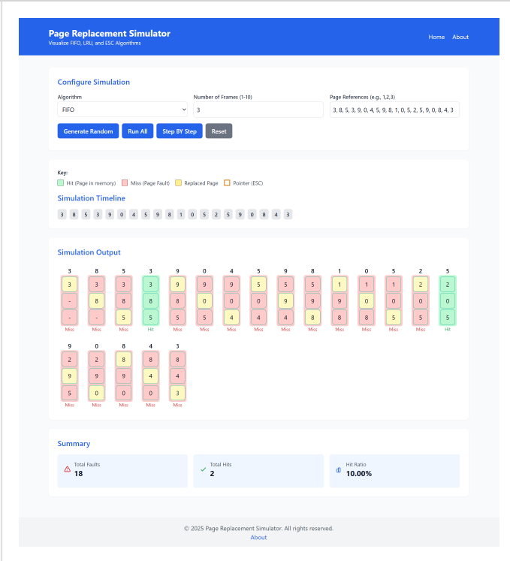

Least Recently Used (LRU)

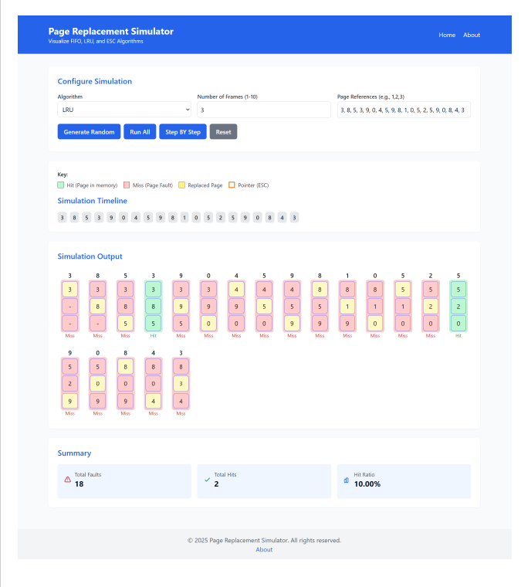
Enhanced Second Chance Algorithm:
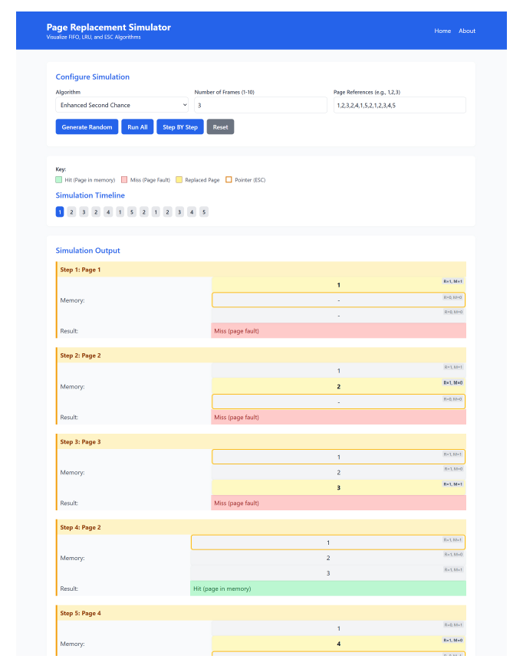

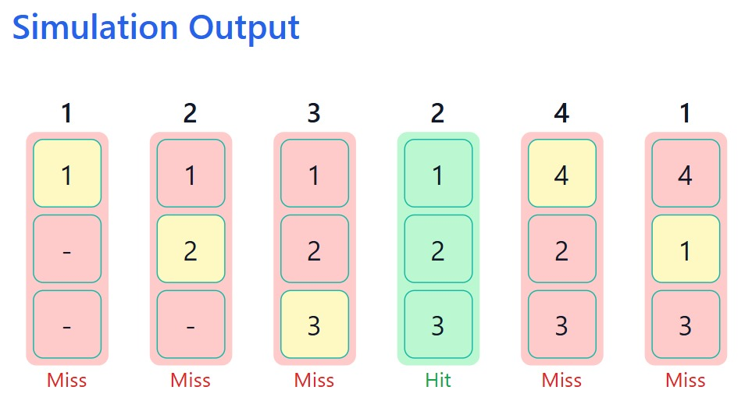

4. Conclusion

The Page Replacement Algorithm Simulator successfully demonstrates the behavior of FIFO, LRU, and Enhanced Second Chance algorithms through an interactive web interface. By leveraging HTML, CSS, and JavaScript, the simulator provides a user-friendly experience with real-time visualizations, including a timeline, memory frame states, and a summary chart. The FIFO algorithm is simple but may evict frequently used pages. LRU improves efficiency by prioritizing recently used pages but requires tracking access order. The Enhanced Second Chance algorithm balances complexity and performance by considering both reference and modification bits, offering a practical approach for operating systems.

